
Longwood University
Personal Training
Contact Information

Name ____________________________________ Date ___________________________

E-mail ____________________________________ Primary Phone __________________

Work Phone _______________________________ LU ID: ________________________

Age: ________ Date of Birth ____/_____/_______ Height ______________

Are you: Undergraduate Student Graduate Student Faculty Staff Spouse/+1

Who would you prefer to be trained by? (Please check the blank below)
_____Male _____Female _____ Any Trainer Trainer Name (if known): __________________________

What are your preferred days/times to train?
Day ________________ Time(s) _____________________
Day ________________ Time(s) _____________________
Day ________________ Time(s) _____________________
Day ________________ Time(s) _____________________
Personal Training Packages
**All sessions must be completed by the end of the school year (May). Sessions left over will be forfeited**
- Fitness Assessment Only (Faculty/Staff/Alumni: $20.00) (Student: $15.00)

- Starter-Pack (Faculty/Staff/Alumni: $54.00) (Student: $45.00)

- Multi-Pack (Faculty/Staff/Alumni: 6 Sessions $120.00) (Student: 6 Sessions $99.00)
(9 Sessions $171.00) (9 Sessions $144.00)
(12 Sessions $216.00) (12 Sessions $180.00)
(15 Sessions $255.00) (15 Sessions $210.00)
(18 Sessions $288.00) (18 Sessions $234.00)

- Buddy Pack (Faculty/Staff/Alumni: 6 Sessions $108.00 each) (Student: 6 Sessions $89.10 each)
(9 Sessions $153.90 each) (9 Sessions $129.60 each)
(12 Sessions $194.40 each) (12 Sessions $162.00 each)
(15 Sessions $229.50 each) (15 Sessions $189.00 each)
(18 Sessions $259.20 each) (18 Sessions $210.60 each)

Longwood University – Personal Training
Exercise History and Goals

Name: ____________________________________ Date: _________________
Emergency Contact: ______________________________ Phone: _____________________________________
Physician’s Name: _______________________________ Physician’s Phone____________________________
Date of last physical examination ____________________
- How would you rate your current knowledge of Health and Fitness?
- Excellent
- Good
- Fair
- Poor

- Please rate your daily stress level:
Low Moderate High, but I enjoy the challenge
High, sometimes difficult to handle High, often too difficult to handle

- Is your occupation
Inactive Light Activity Heavy Activity
(Desk job) (Waitressing) (Construction)

- How many times in a week are you active enough to break a sweat?

- When you exercise, how long are you active? __________________minutes

- On a scale of 1-10 (10 being the greatest), how intense is your physical activity

- How many years have you been exercising? _____________

- If you are currently involved in activities, how many minutes, in a typical week, do you spend engaged in the following:
_____Running/Jogging | _____Stair Climber | _____Weight Training
_____Aerobics | _____Walking | _____Skiing
_____Swimming | _____Biking | _____Yoga/Pilates
_____Racquet Sports | _____Hiking | _____Rock climbing

Please indicate your personal health and fitness goals by answering the questions below
- What are your overall fitness goals? (Ex. Weight loss, muscular strength, Injury rehab, sports specific training, etc.) ______________________________________________

- What has been the hardest part about reaching your fitness goals in the past? (Ex. Too busy, not motivated, unsure of what to do in the gym, etc.)

- Do you have any allergies? _____Yes _____No

- Are you taking any medications or drugs? If so, please list medication, dose and reason.
________________________________________________________________________________________________________________________________________________________________________________________________________________

Do you now, or have you experienced any of the following in the past: YES NO
- History of heart problems, chest pains, or stroke? _____ _____
- Increased blood pressure? _____ _____
- Any chronic illness or infection? _____ _____
- Difficulty with physical exercise? _____ _____
- Advice from a physician not to exercise? _____ _____
- Recent surgery (last 12 months)? _____ _____
- Pregnancy (now or within last 3 months)? _____ _____
- History of breathing or lung problems? _____ _____
- Muscle, joint, or back disorder, or any previous injury still _____ _____
affecting you?
- Diabetes or thyroid condition? _____ _____
- Cigarette smoking habit? _____ _____
- Obesity (More than 20% over ideal body weight)? _____ _____
- Increased blood cholesterol? _____ _____
- History of heart problems in immediate family? _____ _____
- Hernia, or any condition that may be aggravated by lifting _____ _____
weights?
- Has your weight fluctuated more than a few pounds? _____ _____
- Do you sometimes have trouble sleeping? _____ _____
- Have you suffered from migraine headaches? _____ _____
- Have you felt nervous or anxious for no apparent reason? _____ _____
- Have you experienced sudden tingling or numbness in your _____ _____
arms, legs, feet or your face?
- Do you experience pain or cramping in your legs? _____ _____

Please explain any YES answers:
____________________________________________________________________________________________________________________________________________________________________________________________________

Please circle any conditions or diagnosis that applies to you:
Abnormal EKG | Limited Range of Motion | Stroke
Abnormal Chest X-Ray | Arthritis | Epilepsy or Seizures
Rheumatic Fever | Bursitis | Chronic Headaches
Low Blood Pressure | Swollen or Painful Joints | Persistent Fatigue
Asthma | Foot Problems | Stomach Problems
Bronchitis | Knee Problems | Hernia
Emphysema | Back Problems | Anemia
Shoulder Problems | Pregnant | Recently Broken Bones

Has your physician imposed activity restrictions? If yes, please describe:
____________________________________________________________________________________________________________________________________________________________________________________________________

Family History
Heart Attack or heart surgery prior to age 55 | Stroke prior to age 50
Congenital heart disease or left ventricular hypertrophy | Obesity
Hypertension | Asthma
Leukemia or cancer prior to age 60 | Osteoporosis
Diabetes | High Cholesterol

Additional Comments:

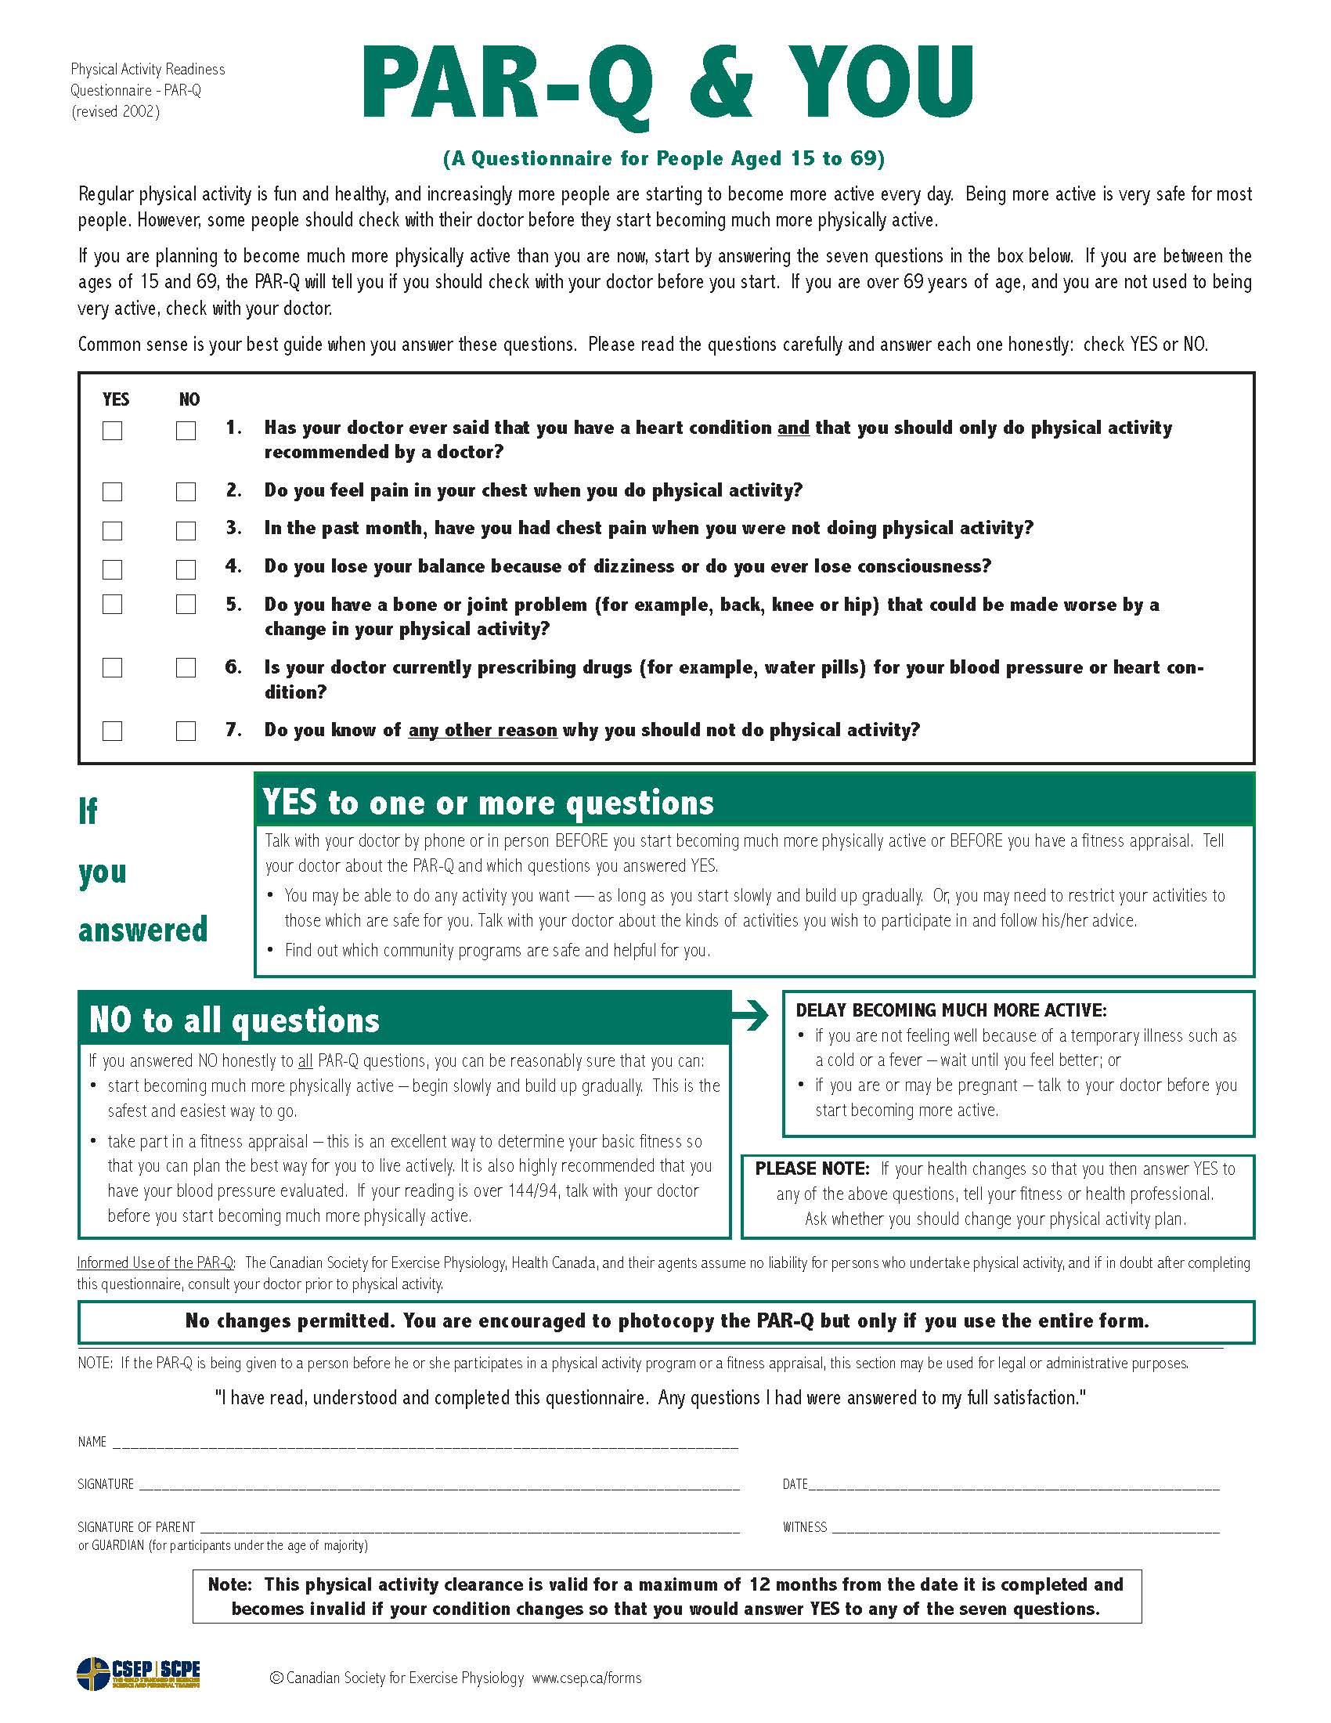

Informed Consent
Longwood University – Personal Training

Assessment and Testing Objectives
All assessment information and results will be emailed or given to you in person. This includes your name,
height, weight, and results.

You may be asked to perform a graded exercise test on a cycle ergometer or treadmill for your assessment. The intensity of the
exercise will progress through stages depending on your current fitness level. The test may be terminated as a result of signs of
fatigue or changes in your heart rate or any symptoms you may experience. You may stop the test at any time if you feel any type of pain or discomfort.

Attendant Risks and Discomforts
The possibility exists for physiological changes to occur during assessment testing including changes in heart rate, breathing, and blood pressure. There are risks such as abnormal changes in blood pressure, fainting, altered heart rhythm, and in rare instances, heart attack. Every effort will be made to minimize these risks based on preliminary examination and observation throughout testing. Emergency equipment and trained personnel are located on-site to deal with unusual situations that may arise.

Responsibility of the Client
Information regarding your previous and/or current health status with physical effort has the possibility to affect the safety of your exercise test. Any symptoms or unusual feelings should be expressed to your trainer immediately so that proper measures can be taken. It is your responsibility to fully disclose your medical history and to report all medications (including non-prescription) to your trainer.

Benefits to be Expected
The results obtained from this test will assist your trainer in developing your individualized program best suited to help you reach your fitness and health goals.

Questions or Concerns
Any questions you have regarding testing parameters, procedures and results are encouraged.

Use of Medical Records
The information obtained during your testing session will be treated as privileged and confidential. It will not be
released or revealed to any individual except your referring physician without prior written consent. The information may however be used for statistical analysis with your right to privacy retained.

Freedom of Consent
I hereby consent to voluntarily engage in an exercise test to determine my exercise capacity and state of
cardiovascular health. My permission to perform this exercise test is given voluntarily. I understand that I am free to
stop the test at any point if I so desire.

I have read this form and I understand the test procedures that I will perform and the attendant risks and
discomforts associated with such a test. Knowing these risks and discomforts, I’ve had the opportunity to
express my questions and concerns which have been answered to my satisfaction. I consent to participate
in this test.

Signature of Client _____________________________________________________ Date _______________

Signature of Trainer ___________________________________________________ Date _______________

Longwood University – Personal Training
Policies and Procedures

Scheduling
- Complete the Personal Training Request Form and Pre-Participation Screening Questionnaire and return to the Office of Campus Recreation
- Pay for packages online or in person at the Office of Campus Recreation in the Fitness Center, Monday through Friday 8:30 am – 5:00 pm
- Direct all questions to the Associate Director of Fitness and Informal Recreation by phone at (434)395-2175 or e-mail at robinsoncn@longwood.edu

Payment Procedures
All payments are to be made in the Office of Campus Recreation prior to the first meeting (fitness assessment) with your trainer. All sessions and packages must be paid in full before training begins.

Cancellation Policy
The client is required to give their trainer an advanced notice of at least 8-hours (unless otherwise agreed upon by both the trainer and client) of any absence. If an 8-hour notice is not received, the client will forfeit that session.

The trainer is not permitted to cancel a session unless it is due to illness or an emergency situation. If the trainer must cancel, they are required to give their client an advanced notice of at least 8-hours.

Tardiness
Clients and trainers are expected to begin all sessions at the scheduled start times. If a client is tardy to a session, that time will be deducted from their training session. The trainer will wait 15 minutes after the scheduled start time after which the entire session will be forfeited.

The trainer is not permitted to arrive late to a scheduled session. If the trainer is tardy, that time will be made up either at that session or in another session (determined by the client). If a trainer fails to show within 15 minutes of the scheduled start time, the client should contact the Associate Director of Campus Recreation and a make-up session will be scheduled.

Refunds
Refunds will only be given for personal training sessions and packages if there is a medically documented reason. If the client is unhappy with their trainer, they should contact the Associate Director of Campus Recreation immediately so that other arrangements can be made.

I have read, been given the opportunity to ask questions and understand the policies and procedures
of Longwood University’s Personal Training Program.

Client Signature __________________________________________ Date ___________________

Trainer Signature __________________________________________ Date ___________________

Longwood University
Campus Recreation
Personal Training Packet

Welcome to the Personal Training Program provided by the Department of Campus Recreation at Longwood University! We are dedicated to providing outstanding fitness and wellness opportunities to the Longwood University community. Each member of our personal training staff has received Campus Recreation fitness training and most hold a nationally recognized certification. Our Personal Trainers are qualified to handle an emergency situation should one arise. We pride ourselves in our ability to accommodate clients of different ages, medical conditions and experience levels. Our qualified staff are prepared to work with you to develop an individualized program and assist you in developing and maintaining a healthy lifestyle.

Your initial assessment will provide you the opportunity to get to know your trainer and to voice any questions or concerns you may have. Your fitness assessment will include heart rate measurements, body composition analysis, flexibility testing, and cardiovascular and muscular fitness assessments. Your exercise program will be designed based on your current fitness level and will take your personal, long-term goals into consideration. Your trainer will be focused on developing an individualized program that incorporates your preferences, abilities and skills.

We are honored that you have chosen our program to guide you on your journey to a healthier lifestyle. We wish you the best with your new training program and are excited to be a part of your transformation. Please contact me at the number below if you have any questions, comments or concerns.

Chelsea Robinson
Associate Director of Fitness and Informal Recreation
(434)395-2175
robinsoncn@longwood.edu

